**SKILL DEVELOPMENT PROJECT-1**

This Article is about our **SKILL DEVELOPMENT PROJECT-1 on FASHION DESIGN SYSTEM.**

**Our Team:**

Team-35

GUDIVADA MANIKANTA BHARGAV SRIRAM-2100030189

RAAVI VEERA VAMSHI-2100030451

MANOJ SANE-2100031602

**Content of article:**

1. **Introduction**
2. **Description**
3. **Application**
4. **Modules**
5. **Survey**
6. **Insights**
7. **Conclusion**

**Introduction**

Fashion is a dynamic global industry that plays an important role in the economic, political, cultural, and social lives of an international audience. Fashion is not about clothing but also includes accessories, footwear, makeup etc.. Fashion is a form of clothing which is related to culture. In different parts of India we can observe unique Fashion style.

**Description**

Fashion Design Software produces the digital blueprint of a design. The main goal of fashion design software is to help designers / users create digital fashion illustrations that communicate their vision of how a design should look once rendered or manufactured in real life.

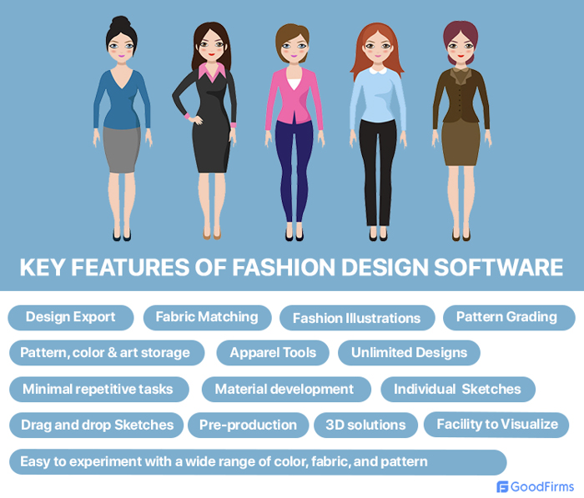

**Application**

We are creating a website on fashion design, which will helps people to find the best design systems, costumes. We are developing a website using the python with the help of Flask/Django and connecting backend through MongoDB or MySQL.

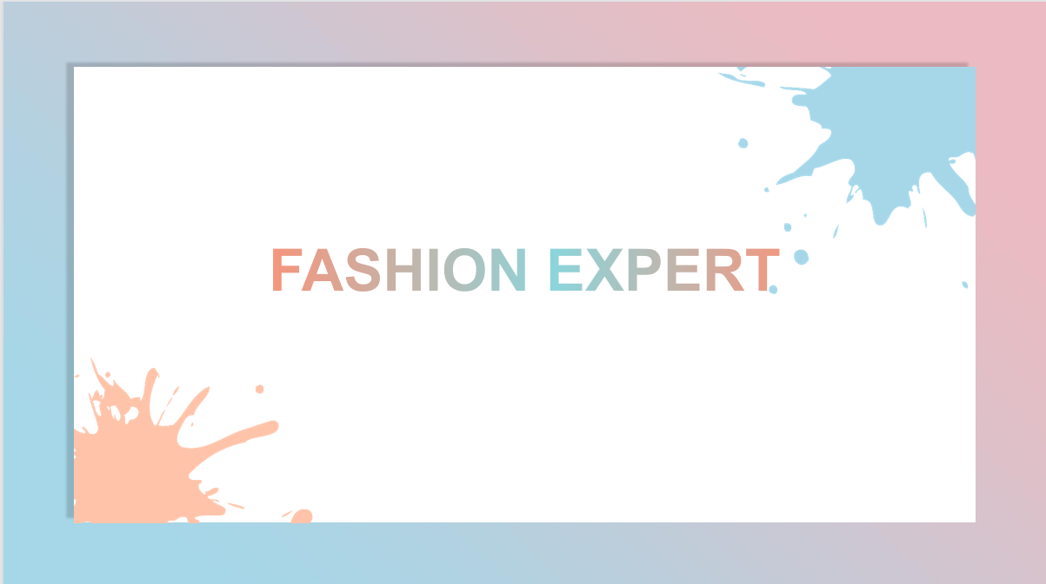**Modules**

We are trying to Design two **modules those are**

* **Designing systems module**

First one is for the customers who wish to find the Designing systems.

Users can find some best Designing systems in this module.

* **Costumes module**

**Second one is to see the costumes as per their interest.**

**Survey**

We collect the Feedback by conducting the survey through Google Form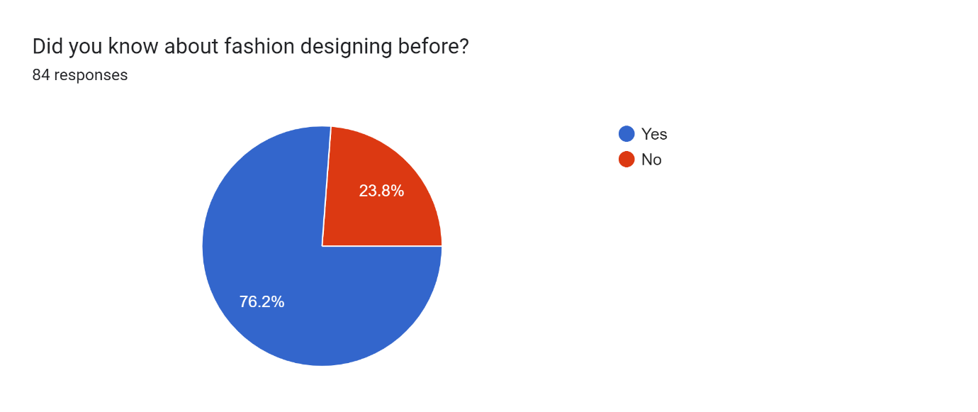

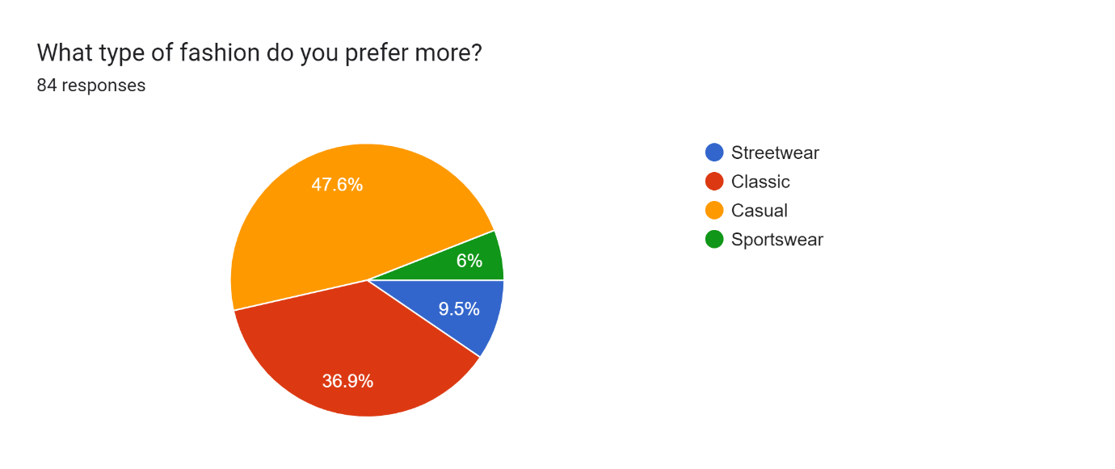

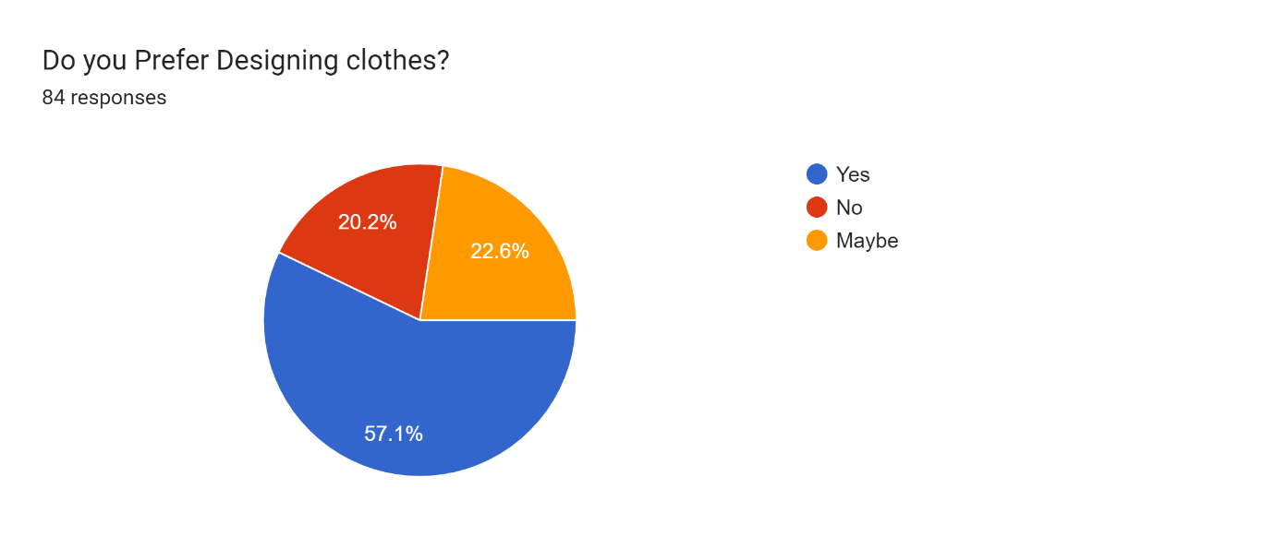

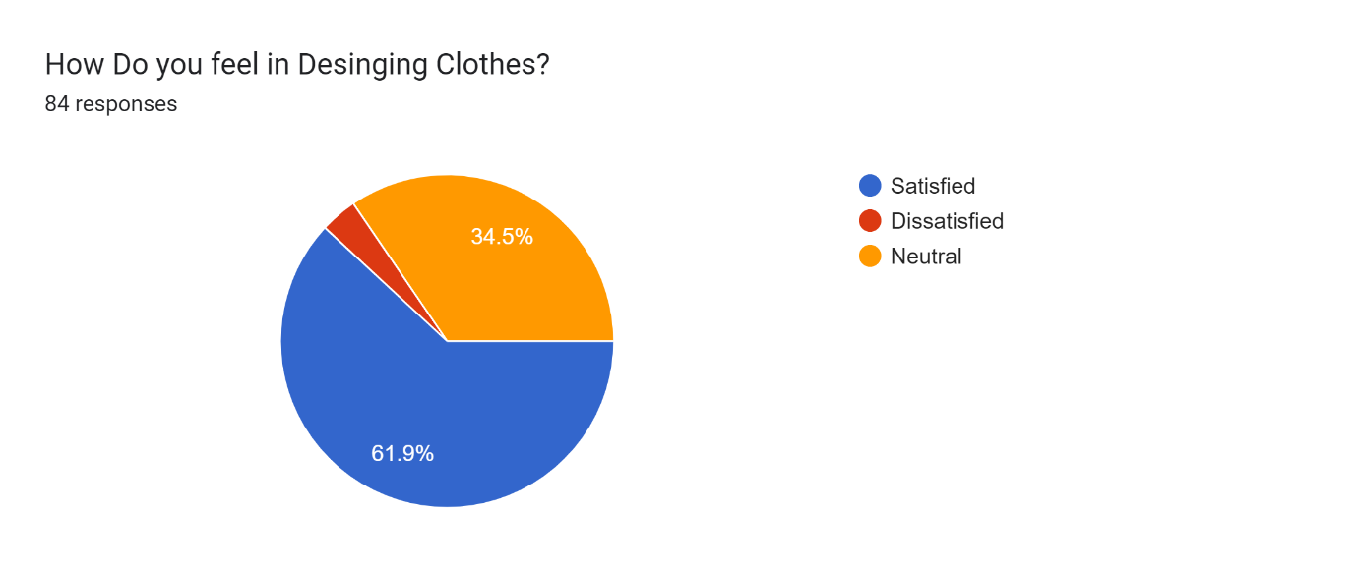

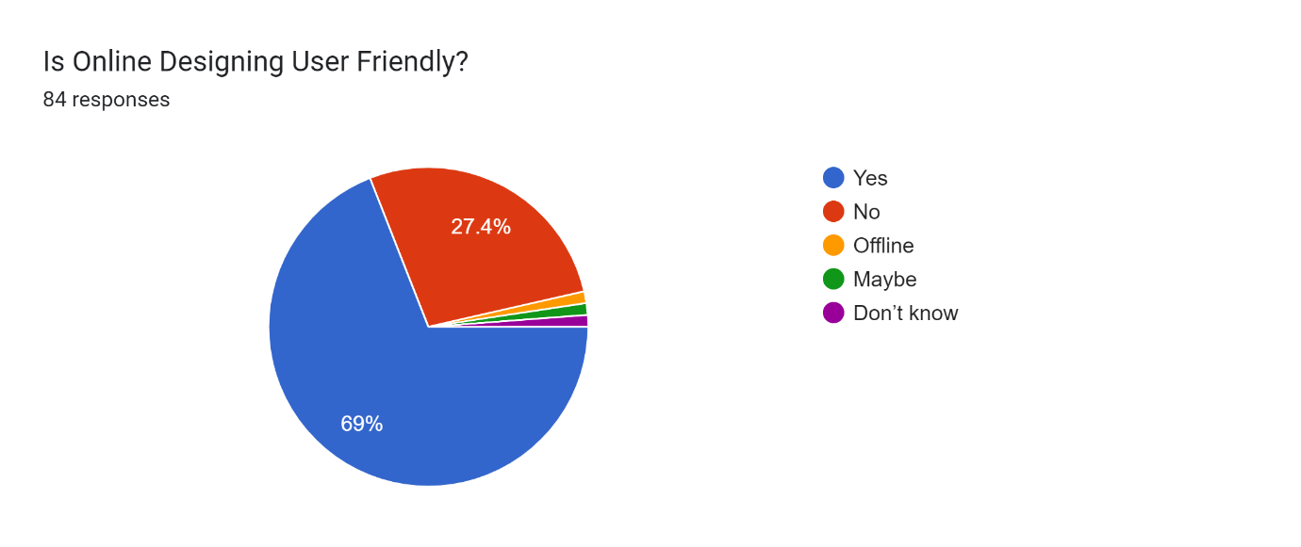

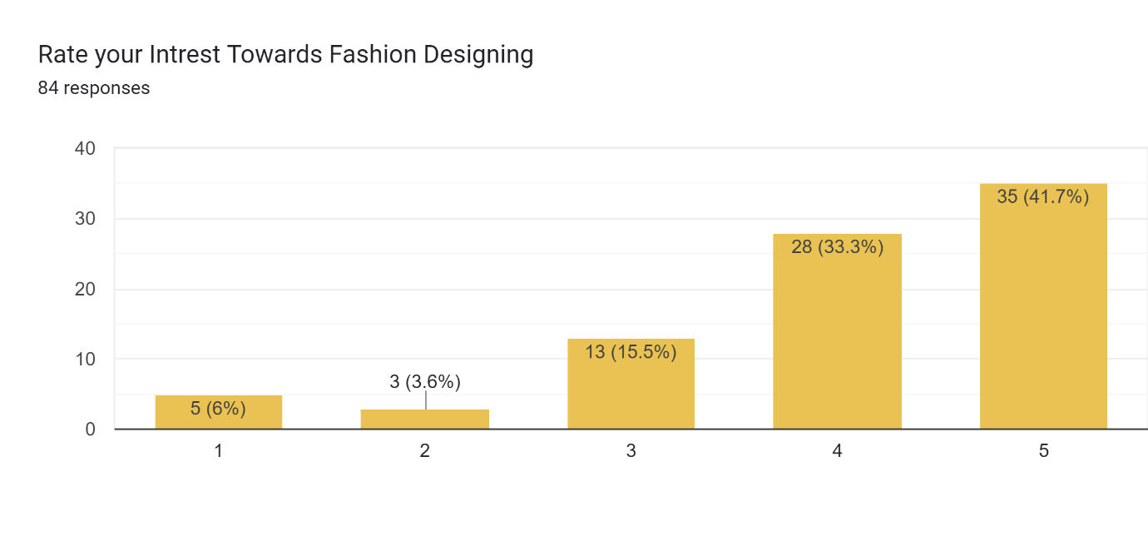

**Insights:**

* People are more interested in Fashion Designing.
* People want to Design different kind of cloths according to their preference.
* Users really wants the Friendly Designing System.
* Users are feeling satisfied to Design clothes through Fashion Designing**.**

**Conclusion:**

* Fashion designing play a vital role in styling the generation. With their skillful designs and vivid colors, this create dresses that exude style. India has a lot of famous fashion designing systems.
* People are very interested in using this type of systems to design according to their convenient
* Users need a simple and friendly systems to design clothes.